
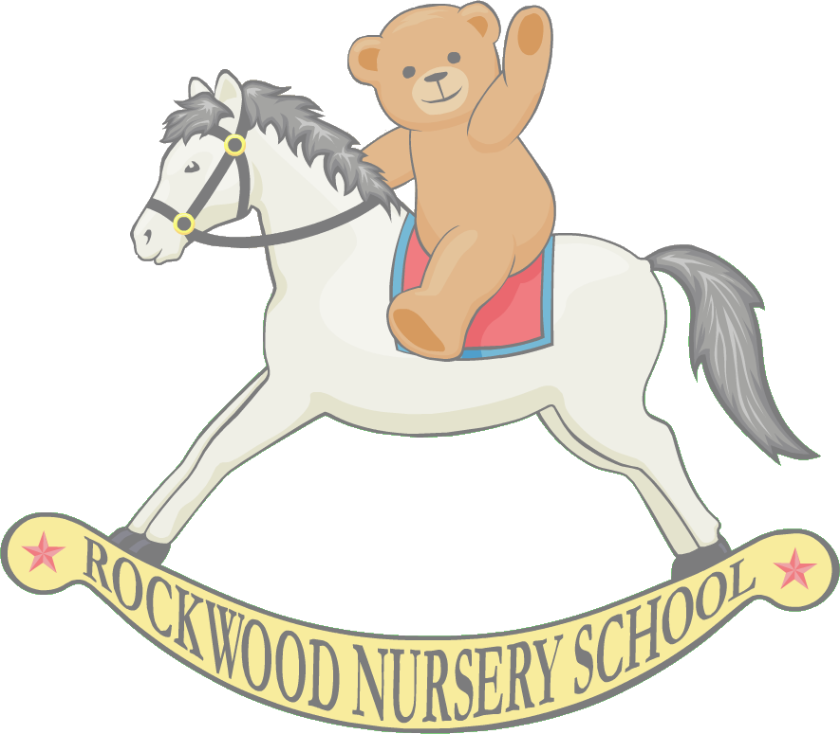
Rockwood Nursery School
Burnley
Kingsland Road
Burnley
BB11 3PU

Tel: 01282 426711
Email: info@rockwoodnursery.com
Head Teacher – Mrs Faith Stringer

29th November 2012

Dear Parent/Carer,
Rockwood Nursery has been awarded the Smile4Life award. This is a programme that has been developed to improve the oral health of children and young people and to lay solid foundations for good oral health throughout life. The programme supports anyone working with children and young people to undertake activities to ensure that the environments in which children spend their time supports both their oral and general health.

Tooth decay is caused by the frequent consumption of foods and drinks containing sugar. Keeping sugary foods and drinks to mealtimes is an effective way to reduce tooth decay and help the children in our care to grow up without the pain and distress that this can cause. This is why as part of the programme we have developed and implemented a Smile4Life snacking policy that ensures:

• Your child is provided only with healthy, sugar-free snacks
• Your child is offered only milk and water to drink between meals
• Exciting ways to celebrate birthdays are used instead of providing cakes, biscuits and/or goody bags (if you wish to bring something for the children to share in celebration we would suggest a book or game that can used in the nursery, thank you.)

The Rockwood Nursery School staff team has worked hard to deliver this programme and achieve accreditation of the Smile4Life award. We would therefore kindly ask parents/carers not to bring drinks, cakes, sweets or any other form of confectionary into Rockwood Nursery School so that we can demonstrate compliance with the Smile4Life snacking policy and continue to be accredited with the Smile4Life award.

If you have any suggestions that would support Rockwood Nursery School in achieving the Smile4Life award or you have any queries or questions, please do not hesitate to contact a member of staff.

Thank you for your support

